
FPC-6004-SO
Foil shielded twisted 4 x AWG24 solid pairs enhanced category 6 cable
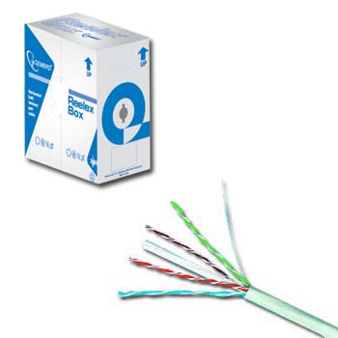
http://www.gembird.com

Specification:
- Structure: bare solid AWG24 (0.51mm diameter) copper cord, PE insulation, FR PVC/LSOH PVC jacket
- Standards met to: ISO / IEC11801, ANSI / TIA / EIA-568B
- Application: horizontal network cabling for 250Mbps: TP-PMD audio, ISDN, ATM, TPDDI, Fast Ethernet

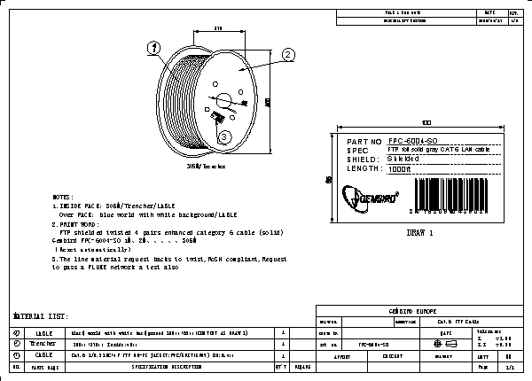
Note this report was made for the full length of 305m:

